**L&T project**

**Title:**

Dynamic solar panel-positioning system

**Problem statement:**

Develop a microcontroller-based solar panel positioning system that offers maximum energy capture from sun-light

**Scope of the solution:**

We measure the intensity of light with LDRs using Arduino and compare the intensity of light falling on both LDRs. The LDRs are placed on the edges of the solar panel as shown in the figure below.

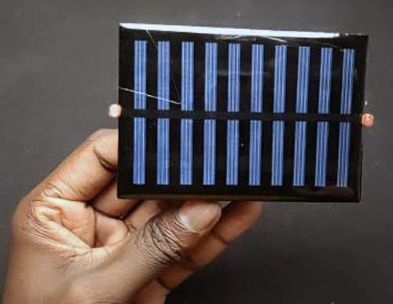

Consider a scenario of a beautiful winter morning, the sun rises from east side and therefore it has more light intensity than the west side, so the panel moves towards to east side. Throughout the day it will track the sun and by the evening, sun has moved towards the west, hence it will have more intensity than the east direction so the panel will face the west direction.

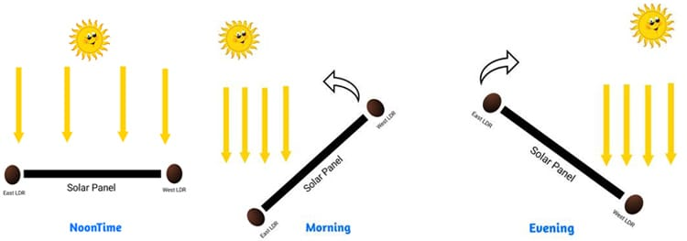

**Required components to develop solution:**

1 x Arduino Uno

1 x Servo motor

1 x Solar panel

2 x LDR

2 x 10k Resistor

Jumper wires

1 x MDF board

**Simulated circuit:**

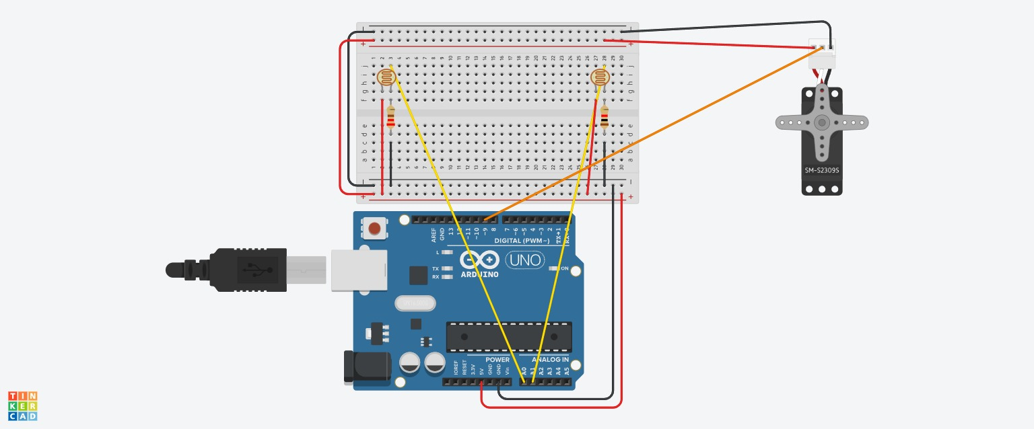

**Video of the demo Gerber file:**



**Gerber File:**

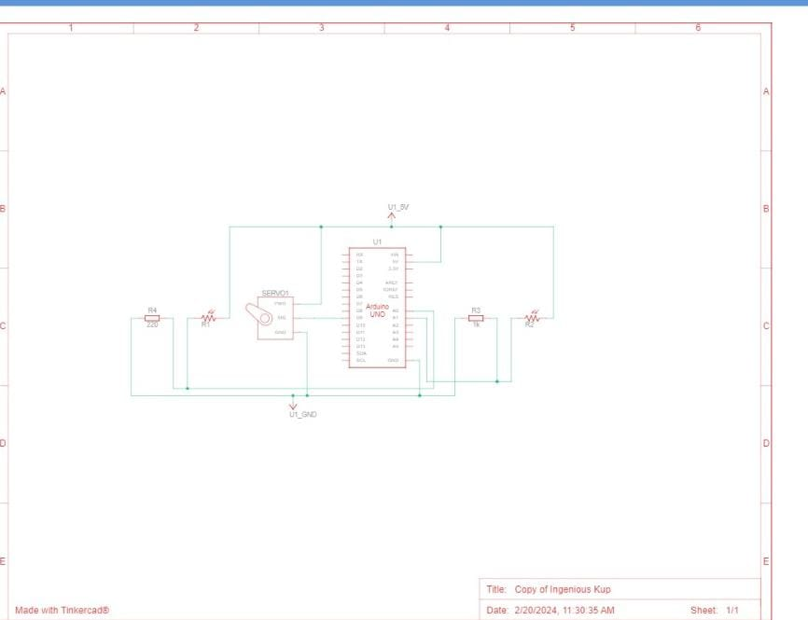

**Code for the solution:**

// C++ code

#include <Servo.h>

int photoresistorValue1;

int photoresistorValue2;

Servo myServo;

const int photoresistorPin = A0;

// Connect the photoresistor to analog pin A0

const int photoresistorPin1 = A1;

void setup() {

Serial.begin(115200);

// Attach the servo to digital pin 9

myServo.attach(9);

}

void loop() {

photoresistor1();

photoresistor2();

servomotor();

}

void photoresistor1()

{

// Read the analog value from the photoresistor

photoresistorValue1 = analogRead(photoresistorPin);

// Print the analog value to the Serial Monitor

Serial.print("Photoresistor Value: ");

Serial.println(photoresistorValue1);

delay(100); // Adjust the delay time based on your application

}

void photoresistor2()

{

// Read the analog value from the photoresistor

photoresistorValue2 = analogRead(photoresistorPin1);

// Print the analog value to the Serial Monitor

Serial.print("2 Photoresistor Value: ");

Serial.println(photoresistorValue2);

delay(100);

// Adjust the delay time based on your application

}

void servomotor()

{

if(photoresistorValue1 == photoresistorValue2)

{

for (int angle = 0; angle <= 180; angle += 1) {

myServo.write(90);

delay(15); // Adjust the delay for smoother movement

}

delay(10); // Pause at 180 degrees

}

if(photoresistorValue1 > photoresistorValue2){

for (int angle = 180; angle >= 0; angle -= 1) {

myServo.write(0);

delay(10); // Adjust the delay for smoother movement

}

}

if(photoresistorValue1 < photoresistorValue2){

for (int angle = 180; angle >= 0; angle -= 1) {

myServo.write(180);

delay(10); // Adjust the delay for smoother movement

}

}

}